AI Assisted Coding
Lab ASSIGNMENT 11.1
K.Mahesh Reddy
2303A510H1
B14
Task Description #1 – Stack Implementation
Task: Use AI to generate a Stack class with push, pop, peek, and is_empty
methods.
Sample Input Code:
class Stack:
pass
Expected Output:
• A functional stack implementation with all required methods and
docstrings.
PROMPT: Genrate the a stack class with this operations push,pop,peek,and is_empty in python
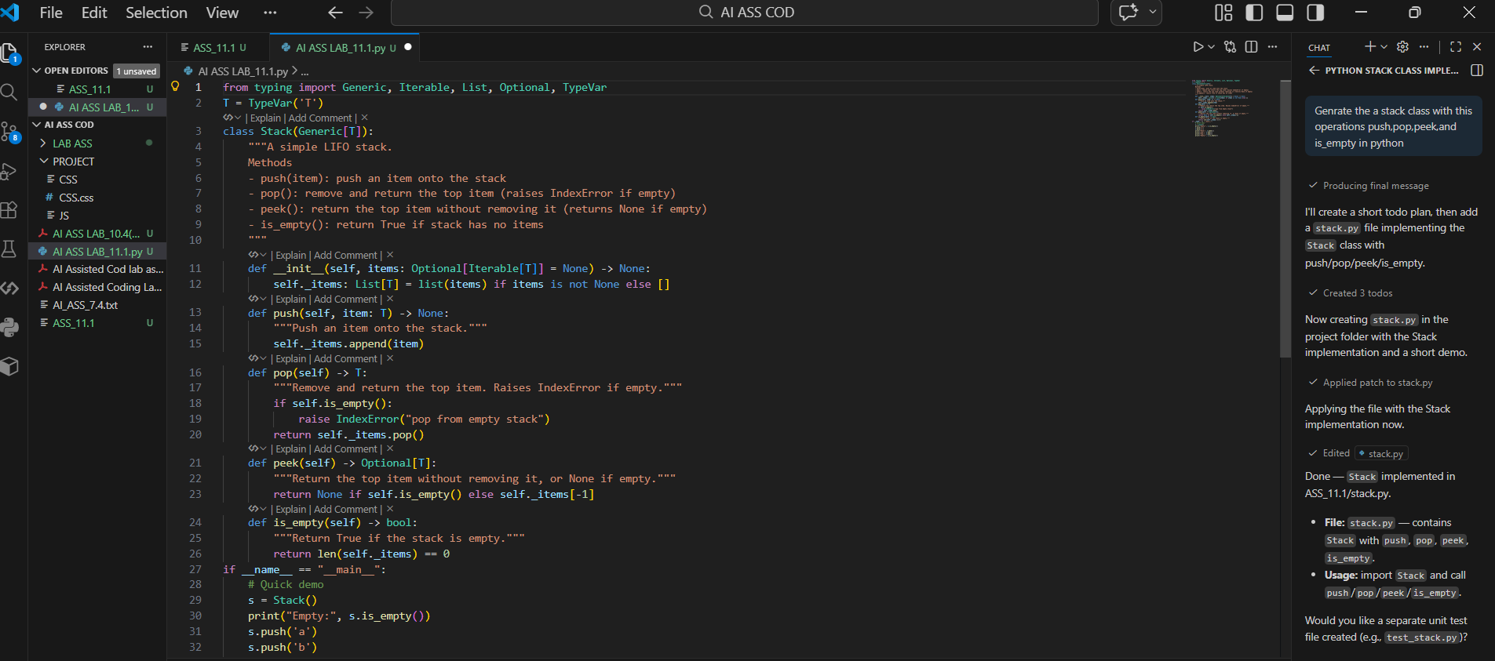
OUTPUT:
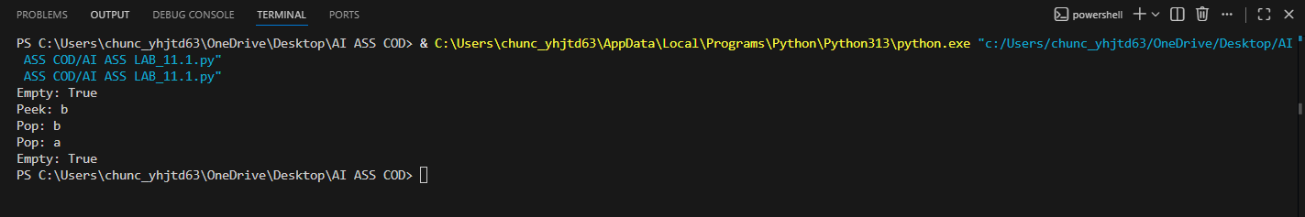
Task Description #2 – Queue Implementation
Task: Use AI to implement a Queue using Python lists.
Sample Input Code:
class Queue:
PROMPT: Generate queue using python list and perform its operations
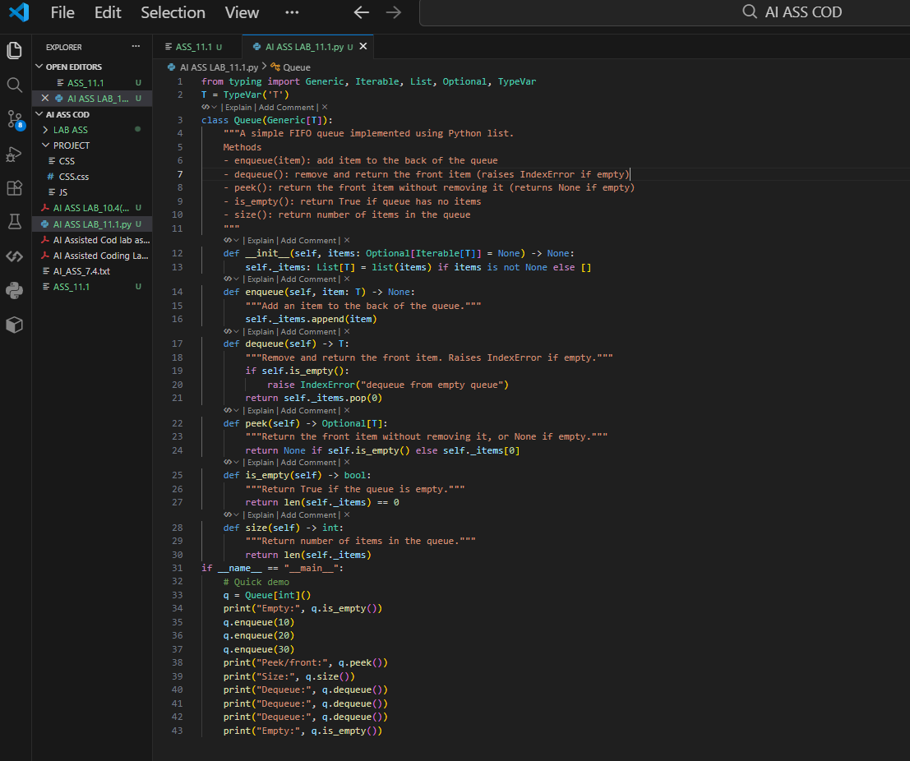
OUTPUT:
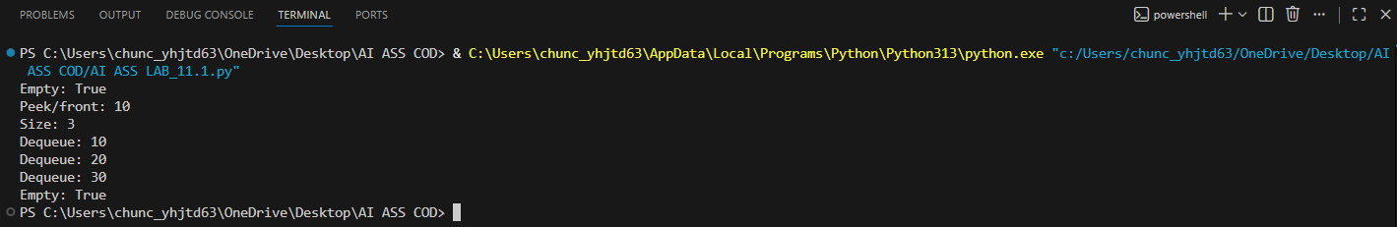
Task Description #3 – Linked List
Task: Use AI to generate a Singly Linked List with insert and display
methods.
Sample Input Code:
class Node:
pass
class LinkedList:
pass
PROMPT: Generate the singly linked list with insert and display methods
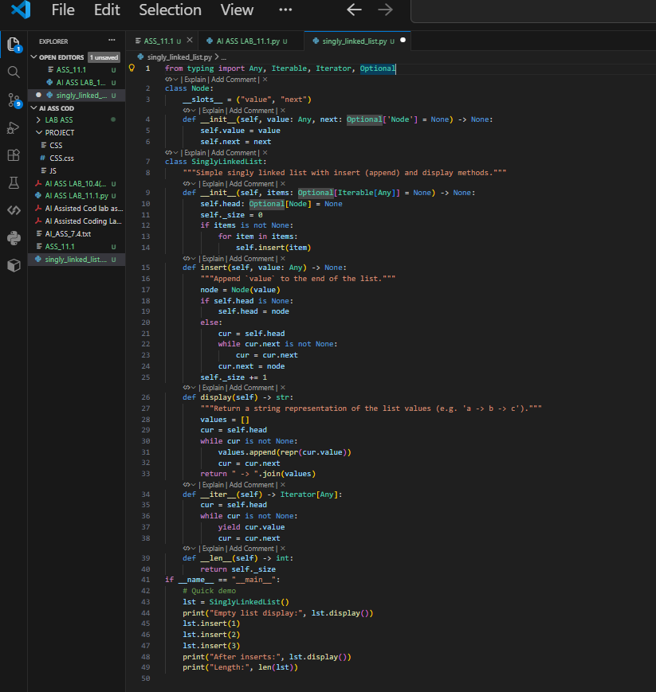
OUTPUT:
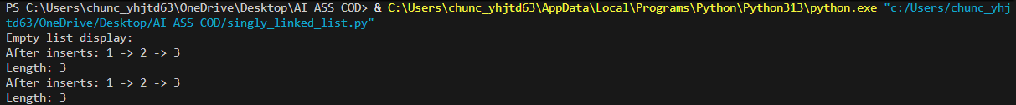
Task Description #4 – Binary Search Tree (BST)
Task: Use AI to create a BST with insert and in-order traversal methods.
PROMPT: Generate the Binary search tree with insert and traverse in-order method
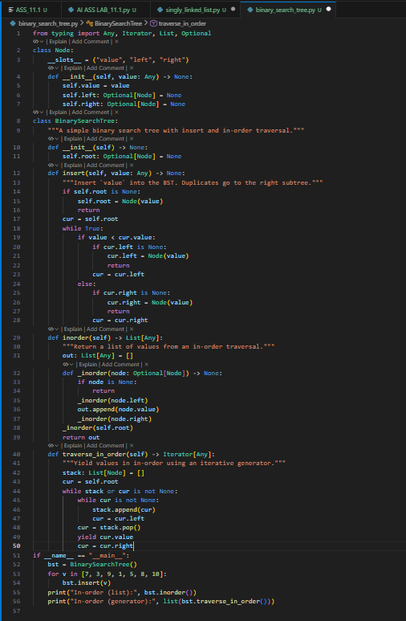
OUTPUT:
Task Description #5 – Hash Table
Task: Use AI to implement a hash table with basic insert, search, and
delete methods.
PROMPT: Generate Hash table with basic insert, search and delete methods
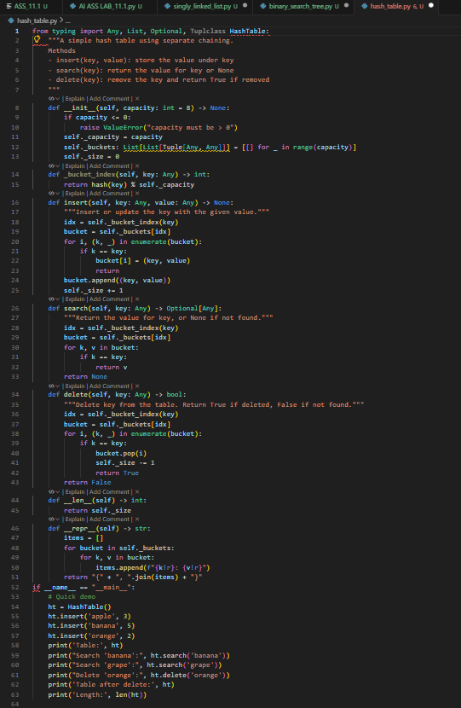
OUTPUT:
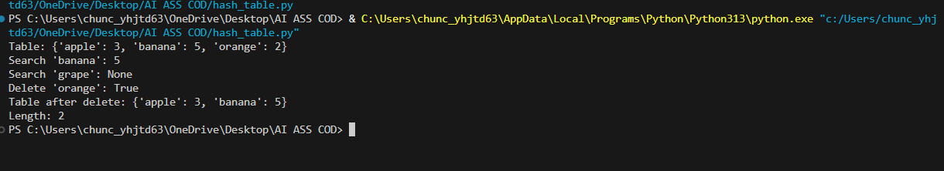
Task Description #6 – Graph Representation
Task: Use AI to implement a graph using an adjacency list.
PROMPT: Generate a graph using an adjacency list
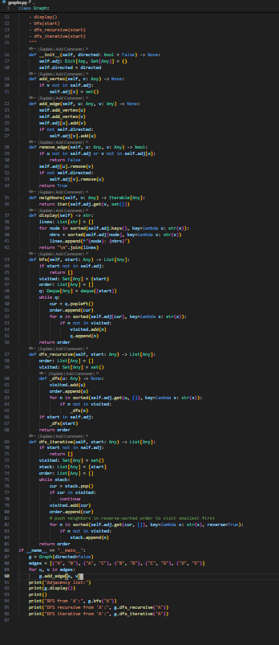
OUTPUT:
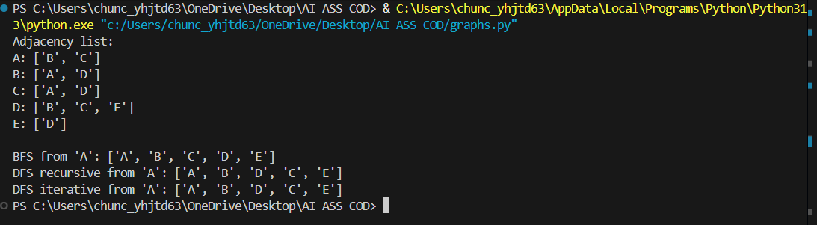
Task Description #7 – Priority Queue
Task: Use AI to implement a priority queue using Python’s heapq PROMPT: Generate priority Queue using py
module.
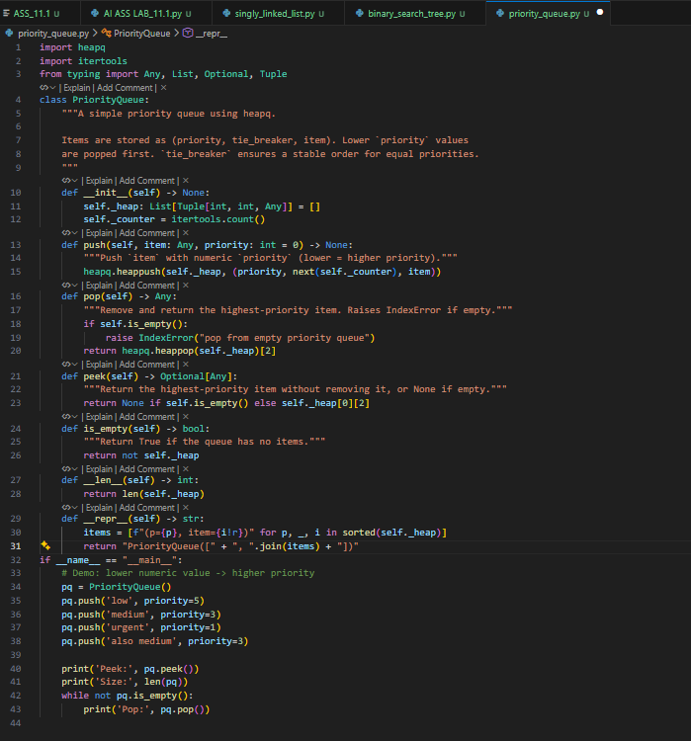
OUTPUT:
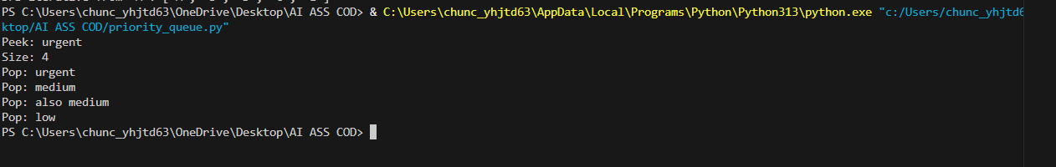
Task Description #8 – Deque
Task: Use AI to implement a double-ended queue using
collections.deque.
PROMPT: Generate a double-ended queue in deque
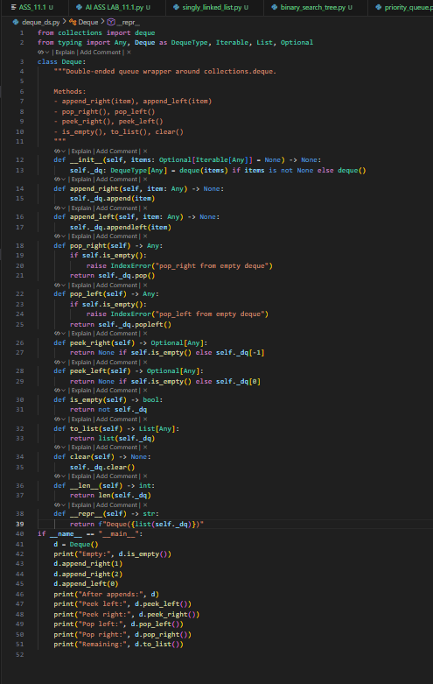
OUTPUT:
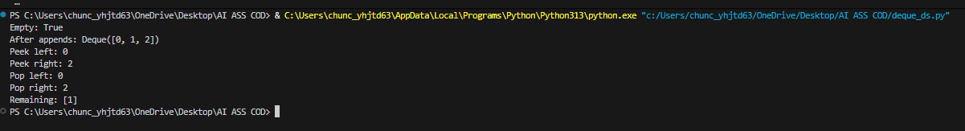
Task Description #9 Real-Time Application Challenge – Choose the
Right Data Structure
Scenario:
Your college wants to develop a Campus Resource Management System
that handles:
1. Student Attendance Tracking – Daily log of students
entering/exiting the campus.
2. Event Registration System – Manage participants in events with
quick search and removal.
3. Library Book Borrowing – Keep track of available books and their
due dates.
4. Bus Scheduling System – Maintain bus routes and stop
connections.
5. Cafeteria Order Queue – Serve students in the order they arrive.
Student Task:
• For each feature, select the most appropriate data structure from
the list below:
o Stack
o Queue
o Priority Queue
o Linked List
o Binary Search Tree (BST)
o Graph
o Hash Table
o Deque
• Justify your choice in 2–3 sentences per feature.
• Implement one selected feature as a working Python program with
AI-assisted code generation
PROMPT:USING ABOVE GENERATE ONE CODE FOR IMPLEMENT
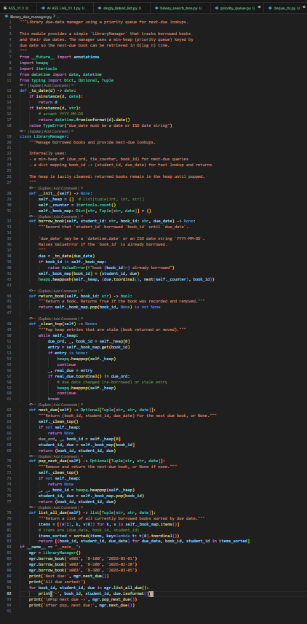
Output:
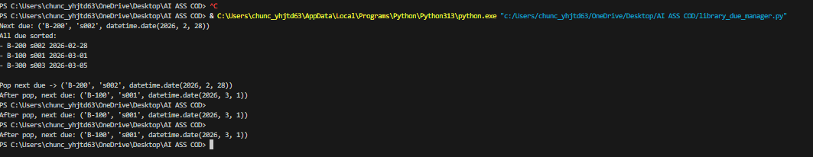
Task Description #10: Smart E-Commerce Platform – Data Structure
Challenge
An e-commerce company wants to build a Smart Online Shopping System
with:
1. Shopping Cart Management – Add and remove products
dynamically.
2. Order Processing System – Orders processed in the order they are
placed.
3. Top-Selling Products Tracker – Products ranked by sales count.
4. Product Search Engine – Fast lookup of products using product ID.
5. Delivery Route Planning – Connect warehouses and delivery
locations.
PROMPT: Select suitable data structures for the given Smart E-Commerce features and justify your choices in 2–3 sentences. Then implement any one feature as a Python program with comments and docstrings.

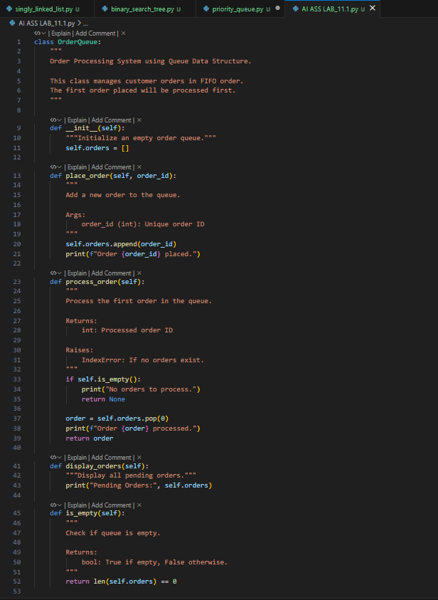
OUTPUT:
